**Lab: SQL injection attack, listing the database contents on non-Oracle databases**

**Problem:** **This lab contains a**[**SQL injection**](https://portswigger.net/web-security/sql-injection)**vulnerability in the product category filter. The results from the query are returned in the application's response so you can use a UNION attack to retrieve data from other tables.**

**Goal:** **You need to determine the name of this table and the columns it contains, then retrieve the contents of the table to obtain the username and password of all users.**

**Solution:**

**1-**

**2-**

4-

**5-**

**6-**

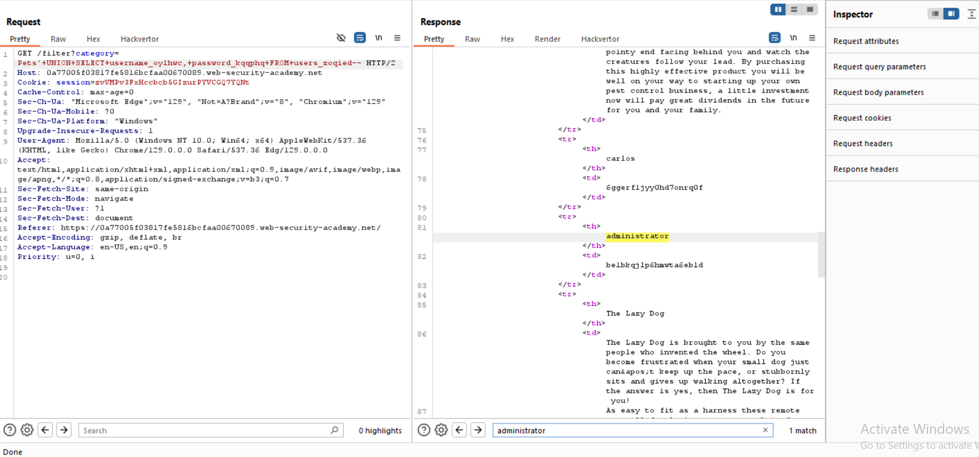

**7-**

